Name:P.Gayathri
Reg.No:192424324

3.Write a Python program to solve the Water Jug Problem.

Aim:
To implement a Python program to solve the Water Jug Problem by obtaining the required quantity of water using two jugs.
Algorithm:
Step 1: Start.
Step 2: Read the capacities of Jug 1 and Jug 2.
Step 3: Read the target quantity of water.
Step 4: Initialize both jugs as empty.
Step 5: Perform the following operations until the target is obtained:
- Fill a jug.
- Empty a jug.
- Pour water from one jug to the other.
Step 6: Display each state after every operation.
Step 7: Stop when the target quantity is obtained in either jug.
Step 8: End.

PROGRAM:
from collections import deque

def water_jug(j1, j2, target):
visited = set()

queue = deque([((0, 0), [])])

while queue:
(a, b), path = queue.popleft()

if (a, b) in visited:
continue
visited.add((a, b))

path = path + [(a, b)]

if a == target or b == target:
for state in path:
print(state)
return

next_states = [
(j1, b),
(a, j2),
(0, b),
(a, 0),
(max(0, a - (j2 - b)), min(j2, a + b)),
(min(j1, a + b), max(0, b - (j1 - a)))
]

for state in next_states:
if state not in visited:

queue.append((state, path))

print("No solution")

j1 = int(input("Enter capacity of Jug 1: "))
j2 = int(input("Enter capacity of Jug 2: "))
target = int(input("Enter target amount: "))

water_jug(j1, j2, target)
INPUT:
Enter capacity of Jug 1: 4
Enter capacity of Jug 2: 3
Enter target amount: 2

OUTPUT:
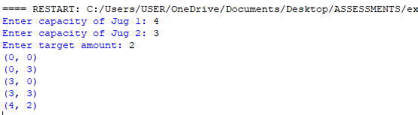

RESULT:
Thus, the Python program to solve the Water Jug Problem was implemented successfully, and the required quantity of water was obtained.

